Supplementary Methods and Results
Using propensity score matching with exact matching on gender and collapsed ethnicity, flexible age modeling, and strong balance diagnostics, we found no detectable association between father incarceration and teacher-reported social–emotional or academic outcomes among Head Start children. Results persisted in Bayesian SEM framework that incorporated clustering by matched sets and model-based handling of outcome missingness. Together with the Head Start program context, these findings suggest that, conditional on observed covariates and within a supported setting, father incarceration did not show an independent adverse association with the studied outcomes in this sample.

Data audit and preprocessing

Duplicate handling
- True duplicate rows (identical across all columns): 2 rows → 1 dropped.
- ID collisions (same child ID with multiple rows): 21 unique IDs. We enforced one record per child using a transparent rule (retain the most complete record on key covariates; tie-break by earliest record). After dropping the exact duplicate row, enforced one row per idnumber: 2016 rows (from 2036)
- Rows before MI after consolidation: 2,016.

Variable renaming
- Renamed I-to-N ratio → I_to_N_ratio; PI → FaInc.
- Dropped non-analytic columns: idnumber, year, birth, entry, AGEM_O, chilfam, adultfam, Family size, income, Poverty threshold, caregiv, parincar.

Descriptive Statistics
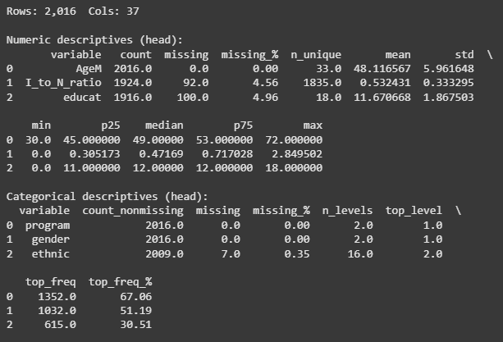

Missing data and multiple imputation (MI)
- We performed MI on covariates only (M = 5 datasets).
- Numeric covariates (AgeM, I_to_N_ratio, educat): IterativeImputer (MICE-style) with posterior draws.
- Categorical covariates: program, gender, ethnic → collapsed to ethnic_collapsed where rare levels < 3% were grouped as Other.
- Treatment (FaInc) and outcomes were not imputed.
- After removing the 176 controls without I_to_N_ratio post-MI, each imputed dataset size was 1,840.
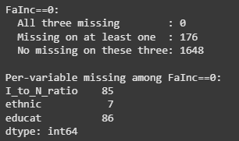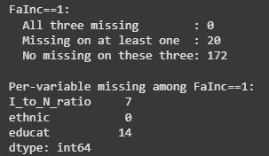
- Per MI set composition: FaInc = 192 (treated), 1,648 controls.

Propensity score matching (PSM)

Specification
- Covariates: program, gender, ethnic_collapsed, AgeM, I_to_N_ratio, educat.
- Encoding & flexibility: one-hot for categorical; spline for AgeM (natural cubic, 5 knots) inside the PS model to capture nonlinearity.
- Propensity model: logistic regression.
- Matching: 1:1 nearest neighbor with replacement on the logit propensity, caliper = 0.2 SD of logit PS.
- Exact matching: gender and ethnic_collapsed (SMD = 0 by design).

Matched samples and balance
- Matched pairs per imputed set: 190–192 (unmatched treated: 0–2 per set).
- 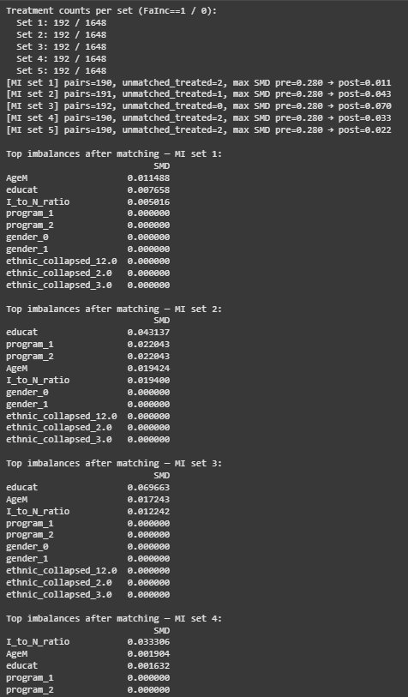
- Balance (max |SMD| across covariates after matching): typically ≤ 0.043, worst-case across sets ≤ 0.070.
- Pre-matching max |SMD| ≈ 0.280.

Per-set balance tables (pre/post SMD).


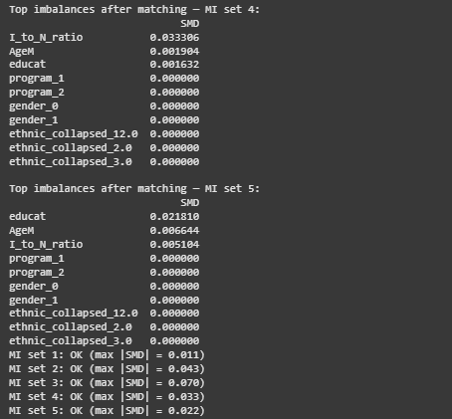

Outcome construction and missingness

PALS harmonization
Two versions of the Phonological Awareness Literacy Screening (PALS-PreK) were used across program years. Variables: pals (older form) and npals (newer form). Each child has one score; 13 children in the full dataset had both missing. We constructed PALS as the first non-missing of (pals, npals).

Outcomes and availability (median across MI sets)
- Social–emotional: selfcont, cooperat, social, initiat → non-missing ~ 380, missing 0 each.
- Literacy: alphknow (377/3), sightwrd (378/2), PALS (375/5).
- Math: numbers (379/1), geometry (379/1), measures (379/1).

Outputs:
outcome histograms per set

Bayesian SEM (primary robustness)

Model
A three-factor measurement model with latent factors and cluster random intercepts:
- Social ← selfcont, cooperat, social, initiat
- Literacy ← alphknow, PALS, sightwrd
- Math ← numbers, geometry, measures
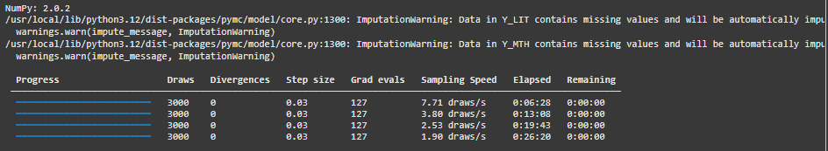
Structural paths: each latent regressed on FaInc and covariates (program, ethnic_collapsed, AgeM, I_to_N_ratio, educat).
Clustering: random intercept by match_set for each latent.
Missing outcomes: handled via Bayesian FIML.

Indicators were z-scored within each MI set for stable priors and interpretable SD-scale effects.

Fitting and pooling
We fit the model separately on each of the 5 MI-matched datasets (0 divergences) and pooled posteriors by concatenating chains (a Bayesian analogue to MI pooling). We report the FaInc coefficient on each latent factor in SD units.

Findings
Posterior means for the FaInc effect on Social, Literacy, and Math latent factors were near zero, and the 95% credible intervals spanned zero for all three factors—convergent with the frequentist results.
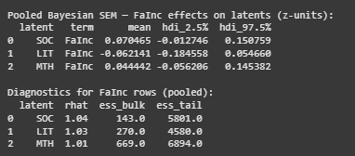
Forest Plot of pooled Bayesian effects
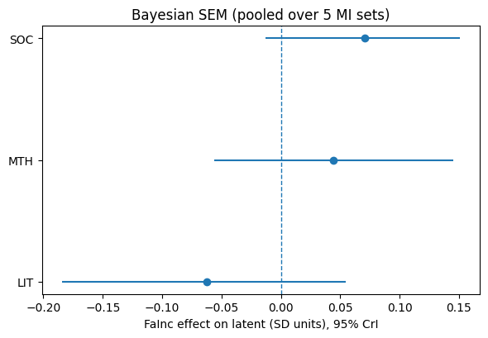

Limitations and context
- Observed-confounder design: PSM balances measured covariates; unmeasured confounding may remain.
- Temporal span (to include in main paper): 10-year data window; cohort/program changes not fully identifiable beyond included covariates.

